Modelling Cancer Treatment Survivability Rate with Weibull Power Function



Omkar Sachin Patankar

James Williams

David Nieves-Acaron

Anshul Maurya

MTH 5411

December 7, 2022

Dr. Nezamoddin Nezamoddini-Kachouie

**TABLE OF CONTENTS**

1 Abstract **3**

**2 Introduction/Background** **4**

2.1 Exploring The Data 4

2.2 The Weibull Power Function 6

2.3 Characterization of the Weibull Power Function 7

2.4 Characterization of the Hazard Function 10

2.5 Background Summary 12

**3 Methodology** **13**

3.1 Creating the MLE and Gradient 13

3.2 Simplifying the Parameters 14

3.3 Initial Parameter Values 15

3.4 Code Used 15

**4 Results** **18**

4.1 MLE Convergence Verification 18

4.2 Estimated Parameters and Data Fitting 19

4.3 Comparing the 3 Datasets 20

5 Discussions/Conclusion **24**

5.1 Conclusion 24

5.2 Challenges 24

6 References **25**

**Appendix** **26**

Phi Convergence Graphs 26

# Abstract

The Weibull Power Function is an altered version of the well-known Weibull distribution. The purpose of this report is to characterize all four parameters of this distribution, and to determine its ability to characterize any particular dataset. Specifically, this report will be using a dataset involving time to failure for cancer patients with data on their most recent physical state, sex, age, and other characteristics. The Weibull Power Function is listed below:

$F\left(t\right)=1-e^{-ν{\left[\frac{t^{λ}}{φ^{λ}-t^{λ}}\right]}^{ω}}, t>0, φ>t$

Throughout this report, it will become necessary to characterize the distribution with different visualization techniques, simplify the 4-dimensional solution space, and use numerical optimization methods to calculate all four parameters given in F(t) to model the probability distribution using the Maximum Likelihood function. Optimization algorithms (the optim and maxLik functions) employed in RStudio were used across a wide array of initial parameters to calculate the parameters that optimize the Maximum Likelihood Function until an accepted level of accuracy was found.

# Introduction/Background

## Exploring The Data

The dataset used in this project consists of medical data detailing the details surrounding a patient’s lung cancer diagnosis and subsequent survival time. The listed fields include the following: inst, which indicates the institution code; time, which indicates the survival time of the patient in days; status, which indicates the censoring status (1 meaning censored, and 2 meaning dead); age meaning the age in years; sex meaning the person’s sex or gender, with a male value evaluating to 1 and a female value evaluating to 2; age referring to the person’s age in terms of years; ph.ecog representing the ECOG performance (a metric used to detail a disease’s progress); ph.karno, representing the physician’s rated karnofsky score (a score referring to a person’s functional impairment with regards to a disease) ; pat.karno, representing the patient’s rated karnofsky score; meal.cal representing the calories consumed for every meal; finally, wt.loss representing the weight loss in the last six months in terms of pounds.

Upon inspection of the dataset, it was found that there is a significantly larger chance of failure when the $t < 420$ days, indicating a positive skew in this regard. Besides that, the age seems to be normally distributed with the average hovering around the 60’s.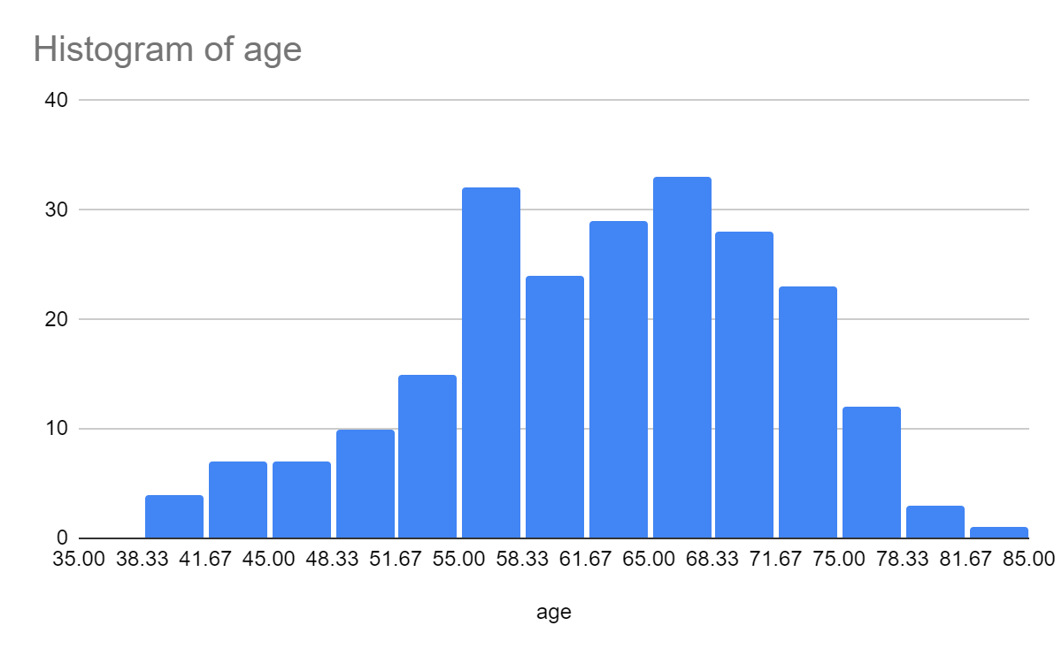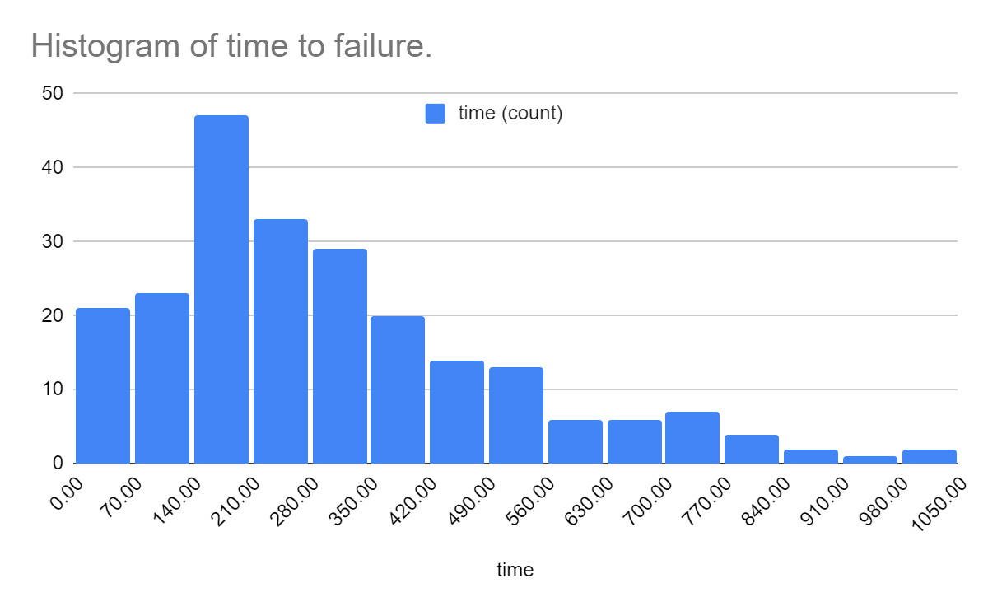

In addition to this, there seem to be significantly more samples of men than there are of women, which led to some repercussions on the parameter estimation in the later sections.

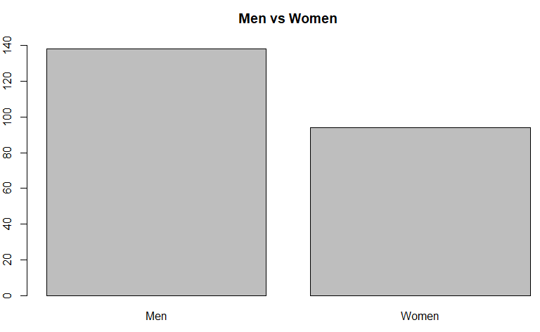

In general, this likely entails for the parameter estimation that this abundance of male samples likely skews the overall results to be more similar to the men’s distribution vs the women.

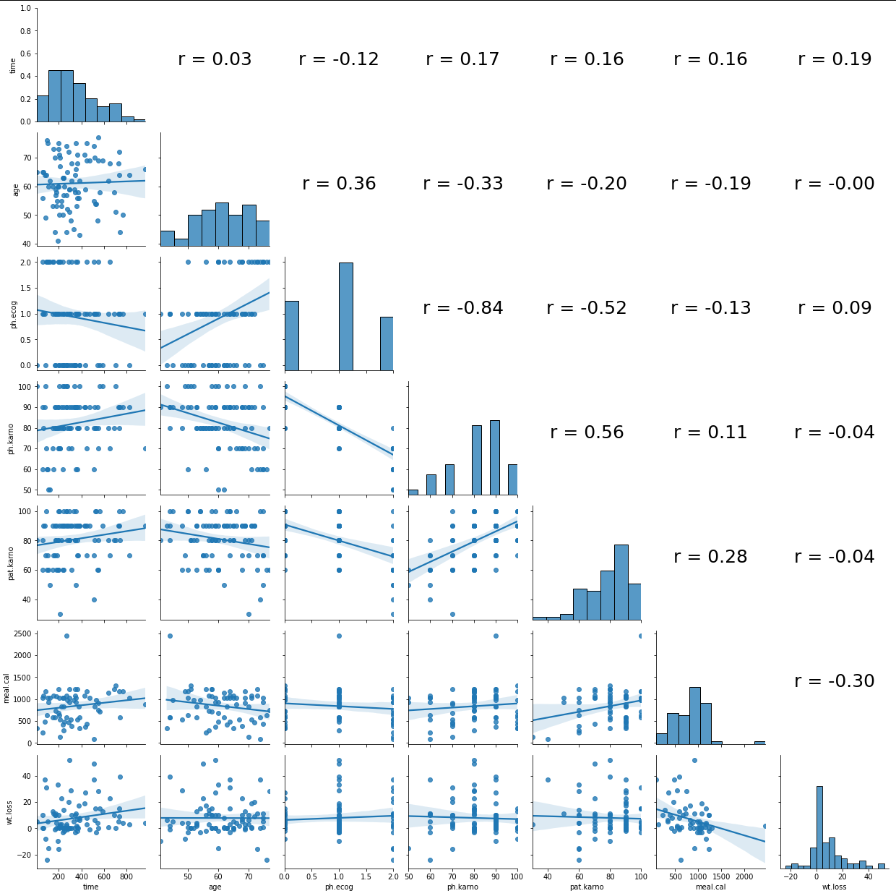

The correlogram above was generated using Python’s Seaborn library. Correlograms can be a very useful tool for analyzing data before attempting any kind of statistical analysis or modeling. On the upper right there are the correlation values for each of the columns and rows of information. Naturally, one only needs to show the bottom left since the top right would be repeated information from the bottom left. The diagonal shows a histogram of each of the fields, whereas the bottom left shows how the selected values of the data relate to each other in a 2D plot.

Based on the correlogram, a somewhat significant relationship between the ph.karno and ph.ecog values as well as the ph.karno and pat.karno values can be seen. However, these relations aren’t terribly important to the discussion since one would expect the ph.karno and ph.ecog values to be related, since they both come from the same source of truth (the patient) and they both relate to how the patient feels he/she is feeling. There are some other correlations such as the one between ph.ecog and pat.karno which follow somewhat similar lines of thought. In general, the data has no 1:1 correlation in the fields that will be analyzed for the Weibull Power Function. The purpose of analyzing the data beforehand is to see which aspects of the data matter and may directly impact the results. Without analyzing the data beforehand, it can be difficult to understand how best to model the data.

## The Weibull Power Function

The Weibull Power function attempts to extend the well-known Weibull distribution to give more control over the distribution. From Tahir et al (see References, Lemma 2.1 of the paper), it can be seen that a Weibull Power Function is a composition of a random variable $Y$ with a weibull distribution in the following manner:

$α [\frac{Y}{1 + Y}]^{(\frac{1}{β})}$

While the Weibull distribution has shape parameters $a,b$, the Weibull Power Function has shape parameters $a,b,α,β$.

The hazard function provided by the Weibull distribution is a more generalized lifetime function. Since our dataset of cancer patients needs something based on real lifetime models, choosing the Weibull function to model our data should be our obvious choice. However, the first calculation needed is the probability distribution (PDF), f(t), and our hazard function, H(t), from the previously listed cumulative probability distribution (CDF) F(t).

Deriving f(t):

$f\left(t\right)=F^{'}\left(t\right)=d/dt\left(1-e^{-ν{\left[\frac{t^{λ}}{φ^{λ}-t^{λ}}\right]}^{ω}}\right)=e^{-ν{\left[\frac{t^{λ}}{φ^{λ}-t^{λ}}\right]}^{ω}}*\left[\left(νt^{λω-1}λω\right)*{\left(φ^{λ}-t^{λ}\right)}^{-ω}+\left(νt^{λω}\right)*{\left(φ^{λ}-t^{λ}\right)}^{-ω-1}\left(-ω\right)*\left(-λt^{λ-1}\right)\right]=e^{-ν{\left[\frac{t^{λ}}{φ^{λ}-t^{λ}}\right]}^{ω}}*\left[\frac{νωλt^{λω-1}\left(φ^{λ}-t^{λ}\right)}{{\left(φ^{λ}-t^{λ}\right)}^{ω+1}}+\frac{νωλt^{λω}t^{λ-1}}{{\left(φ^{λ}-t^{λ}\right)}^{ω+1}}\right]=e^{-ν{\left[\frac{t^{λ}}{φ^{λ}-t^{λ}}\right]}^{ω}}*\left[\frac{νωλt^{λω-1}φ^{λ}-νωλt^{λω-1+λ}+νωλt^{λω+λ-1}}{{\left(φ^{λ}-t^{λ}\right)}^{ω+1}}\right]=e^{-ν{\left[\frac{t^{λ}}{φ^{λ}-t^{λ}}\right]}^{ω}}\frac{νωλt^{λω-1}φ^{λ}}{{\left(φ^{λ}-t^{λ}\right)}^{ω+1}}$

Therefore, $f\left(t\right)=\frac{νωλφ^{λ}t^{ωλ-1}}{{\left[φ^{λ}-t^{λ}\right]}^{ω+1}}e^{-ν{\left[\frac{t^{λ}}{φ^{λ}-t^{λ}}\right]}^{ω}}$

Since each value of F(t) and f(t) must be between 0 and 1, and that the data has a maximum t value of 1022, assumptions can be made for the entire dataset:

$ν,ω,λ>0, and φ>1022≥t>0$

Calculating h(t):

$h\left(t\right)=\frac{f\left(t\right)}{S\left(t\right)}=\frac{f\left(t\right)}{1-F\left(t\right)}=\frac{νωλφ^{λ}t^{ωλ-1}}{{\left[φ^{λ}-t^{λ}\right]}^{ω+1}}$

The regular Weibull distribution is

$F\left(t\right)=1-e^{-{\left[x/λ\right]}^{k}}$

Given the PDF and CDF equations above, it can be seen that there are direct comparisons to the original Weibull equation shown above. For example, creating the comparison of k = $λ$ $ω$*, can change the hazard and overall CDF in many ways, and this detail will be explored in other sections. Comparing both the equations, it can be seen that there are two extra parameters which will add plenty of complexity to the solution space.

## Characterization of the Weibull Power Function

From *F(t),* there are four parameters that control the Weibull CDF. In order to characterize the parameters for this model, we will fix any three parameters at a time and iterate over a non-fixed variable. The below graph shows an example of the approach mentioned above. The parameters $ω$, $λ$, and φ are fixed and varying the $ν$.

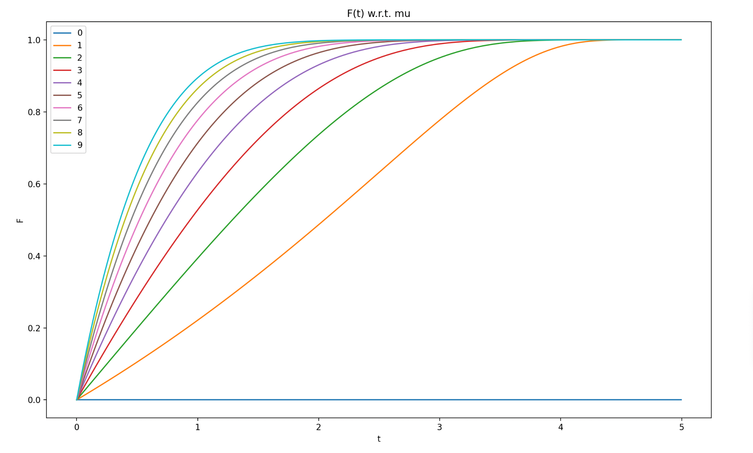

Naturally, F(t) convergences as expected at 1. However, more notably, it can be seen that as $ν$ changes from 0 to 9, that this parameter is determining the initial steepness of the distribution’s curve. Clearly, it can be seen that $ν$ =0 is not a valid value since F(t)=0 at this value. Repeating the same procedure with the other three parameters leads to different variations of the CDF.

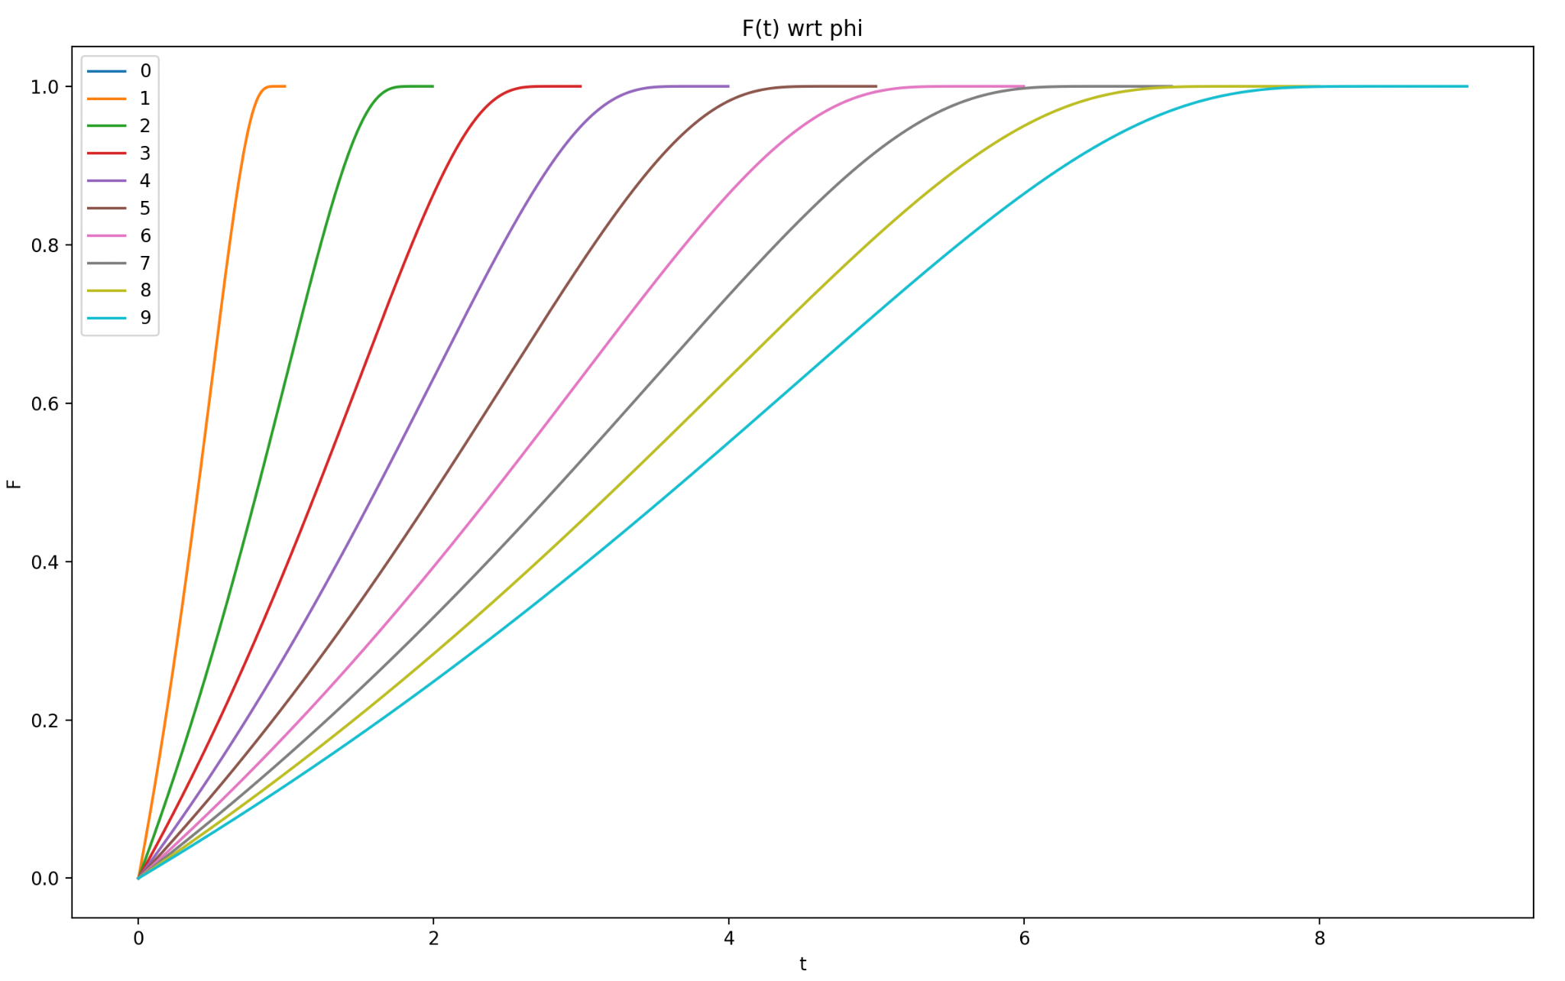

As $φ$ changes, it is clear that the φ determines the domain of F(t). Since the overall limitation of φ>t on the model, the distribution has a clearly bounded solution space for t to be between 0 and φ. Regardless of the value of φ, the CDF will always reach its maximum value of 1 just before reaching φ.

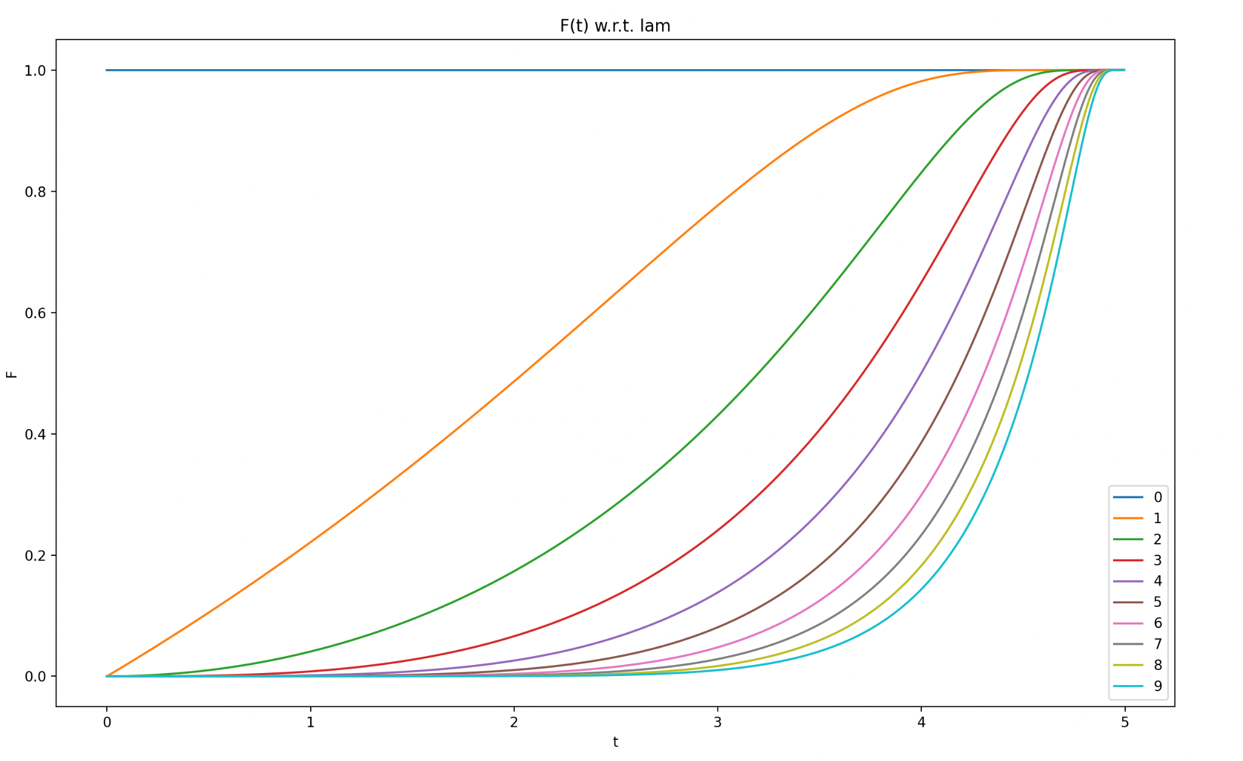

While $ν$ determining the CDF’s “top” curve as it converges to 1, it can be seen that $λ$ it determines the CDF’s “bottom” curve before it takes a steep turn toward 1. Overall, as $λ$ is changing from 0 to 9, it determines how late the distribution begins its initial “s” curve.

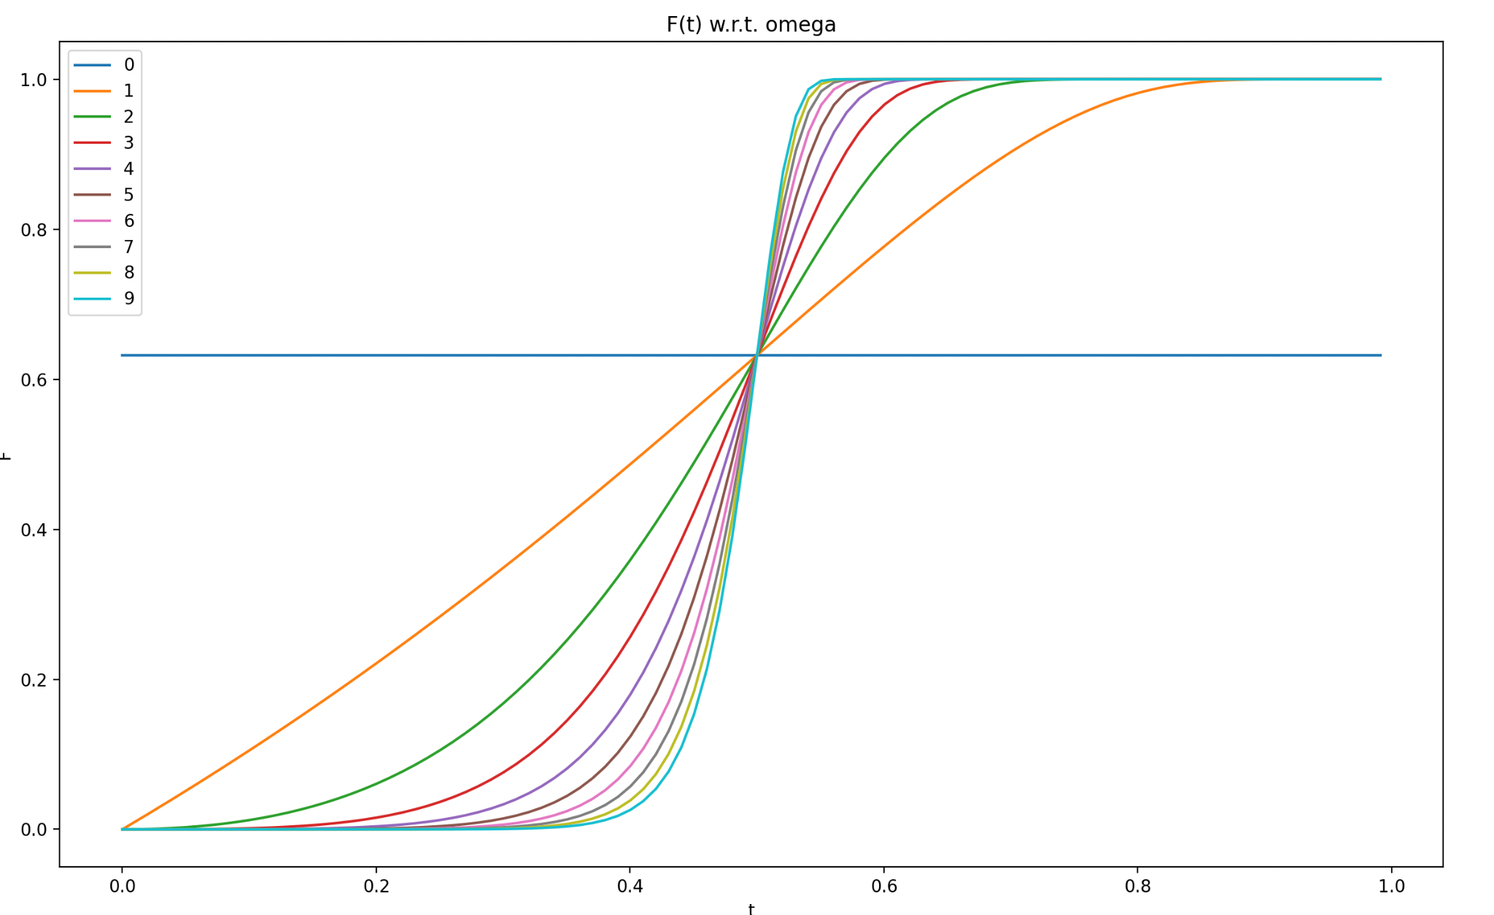

As seen above, $ω$ determines the curve's steepness after its initial turn upwards but before the second curve towards its convergence to 1. This can be determined by the fact that each of the curves crosses the same point in the middle of the distribution (which is determined by the combination of the other 3 parameters).

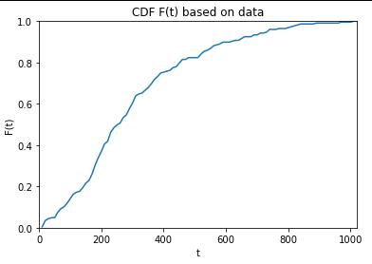

The above graph shows the CDF that the provided lung cancer shows. After characterizing the parameters and visualizing the data in this way, it can be seen that the following trends for an initial guess at the estimated parameters:

* A straight line upwards at the start means that there is either a small λ, or a large λ and a small ω*λ.
* A φ value larger than the max t value of the dataset is needed to determine the right bound of the graph.
* The final part of the distribution curve suggests a median value for μ (approx 5 or 6).
* The near-standard line for the first half of the distribution suggests a low value for ω (approx 1).

## Characterization of the Hazard Function

Repeating the same procedure as we did above for F(t) on our hazard function, h(t),will generate the below graphs:

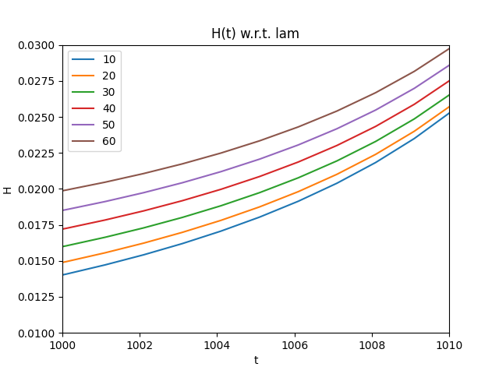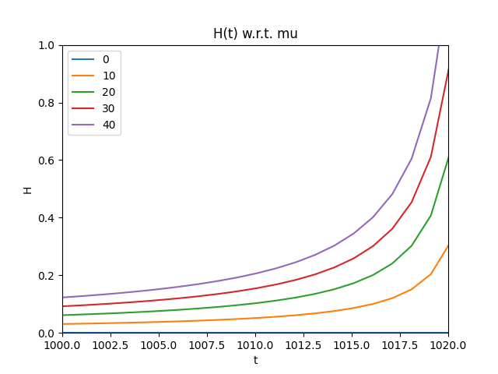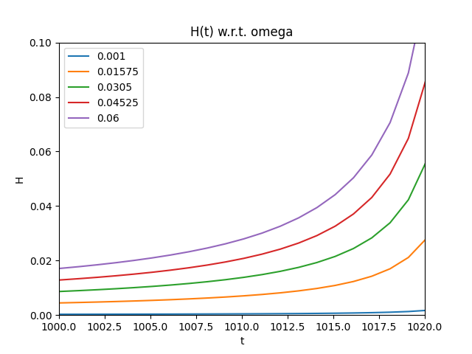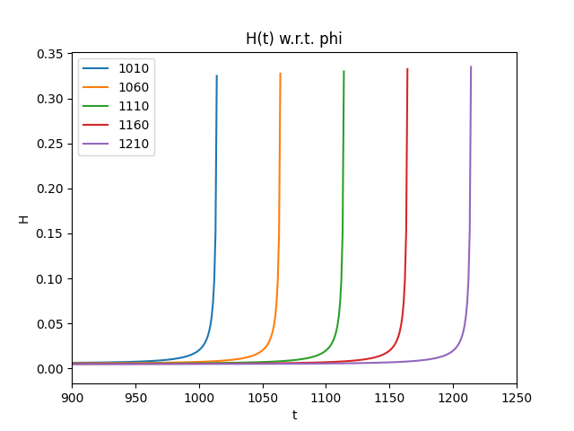

As shown from the above hazard plots, all 4 parameters seem to change the hazard function similarly, but there is not a clear difference in how each of the parameters changes the hazard function (aside from the obvious right limit in the domain from φ. There is extra changes in shape when looking specifically at the parameters ω and λ, as shown below.

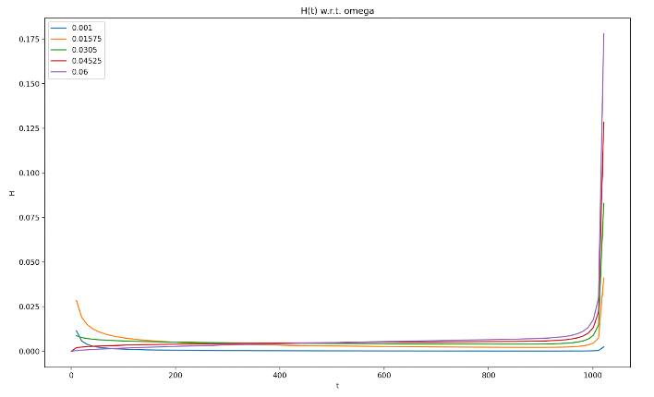 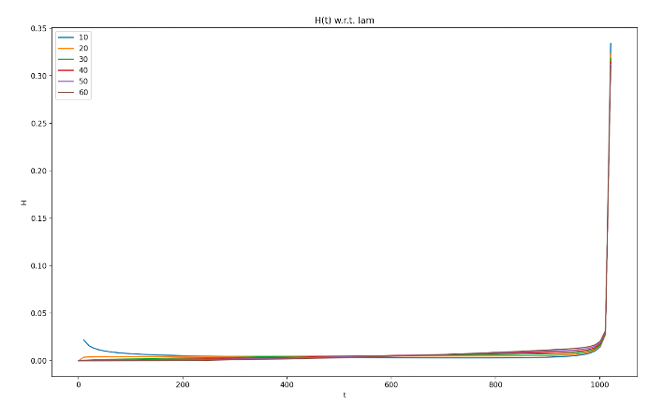

When looking closely at the pictures above, it can be seen that the shape of the hazard function changes from a steady increasing function to a bathtub-like shape based on the changes in curvature in the initial values of t. These two parameters are the only ones to change the shape for a specific reason. As noted earlier, there is a direct relationship with k = λ * ω from the original Weibull distribution. Specifically, when k < 1, then the hazard will see a bathtub shape, and it will have a steady increase otherwise (see Tahir et al. Theorem 2.3). A zoomed in view of these curves are seen below.

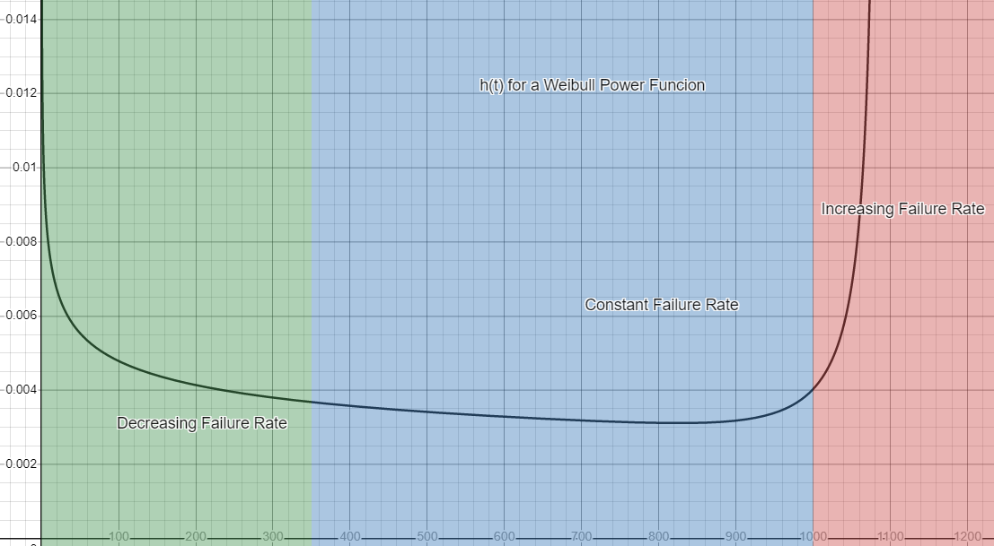

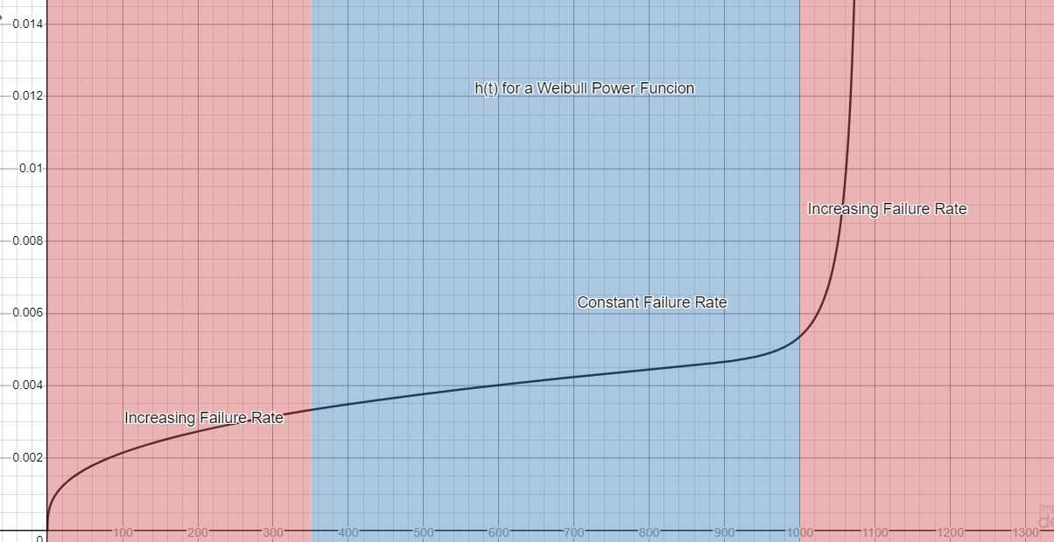

## Background Summary

As seen from the above introduction of this model, each of the parameters for *F(t)* and *h(t)* significantly change the curve of the probability distributions. It can be visually seen from the above graphs to determine what set of initial parameters would be best as a first guess during the numerical methods described later. The Weibull Power distribution could be helpful in real life application of reliability analysis as its plots can take many different shapes by controlling the function’s parameters, thus allowing it to have adaptability for many different situations.

# Methodology

## Creating the MLE and Gradient

One of the most common methods to determine the values of the parameters for a given distribution is to calculate the Maximum Likelihood Estimation for f(t), and then maximize this equation to give the best output. However, this alone can prove to be computationally complex, so taking the natural logarithm of this equation will give the same optimal result for the parameters.

$MLE\left(ν,ω,λ,φ\right)=\prod_{i=1}^{n}{}f\left(t\right)=\prod_{i=1}^{n}{}\frac{νωλφ^{λ}t^{ωλ-1}}{{\left[φ^{λ}-t^{λ}\right]}^{ω+1}}e^{-ν{\left[\frac{t^{λ}}{φ^{λ}-t^{λ}}\right]}^{ω}}$

Where the product is in reference to each of the values of t in the given dataset. Since the MLE is unusable in this form, the log-likelihood (L) will need to be calculated, as well as each of the partials:

$L=ln\left(MLE\left(ν,ω,λ,φ\right)\right)=\sum_{i=1}^{n}{}ln\left(\frac{νωλφ^{λ}t^{ωλ-1}}{{\left[φ^{λ}-t^{λ}\right]}^{ω+1}}e^{-ν{\left[\frac{t^{λ}}{φ^{λ}-t^{λ}}\right]}^{ω}}\right)=n\left[ln\left(ν\right)+ln\left(ω\right)+ln\left(λ\right)+λln\left(φ\right)\right]+\sum_{i=1}^{n}{}\left[\left(ωλ-1\right)ln\left(t\right)-\left(ω+1\right)ln\left(φ^{λ}-t^{λ}\right)-ν{\left[\frac{t^{λ}}{φ^{λ}-t^{λ}}\right]}^{ω}\right]$

In order to perform the maximization of this equation, the partials for each of the four parameters will need to be calculated, and then determined if this is truly a maximization of L (and thus, the MLE). These equations turn out to be the following:

$\frac{δL}{δν}=\frac{n}{ν}-\sum_{i=1}^{n}{}{\left[\frac{t^{λ}}{φ^{λ}-t^{λ}}\right]}^{ω}$

$\frac{δ^{2}L}{{δν}^{2}}=\frac{-n}{ν^{2}}<0$

$\frac{δL}{δω}=\frac{n}{ω}+\sum_{i=1}^{n}{}\left[λln\left(t\right)-ln\left(φ^{λ}-t^{λ}\right)-ν{\left[\frac{t^{λ}}{φ^{λ}-t^{λ}}\right]}^{ω}*ln\left(\frac{t^{λ}}{φ^{λ}-t^{λ}}\right)\right]$

$\frac{δ^{2}L}{{δω}^{2}}=\frac{-n}{ω^{2}}-\sum_{i=1}^{n}{}\left[ν{\left[\frac{t^{λ}}{φ^{λ}-t^{λ}}\right]}^{ω}*\ln^{2}\left(\frac{t^{λ}}{φ^{λ}-t^{λ}}\right)\right]<0$

$\frac{∂L}{∂λ}=n\left[ln\left(ν\right)+ln\left(ω\right)+ln\left(λ\right)+λln\left(φ\right)\right]+\sum_{i=1}^{n}{}\left[\left(ωλ-1\right)ln\left(t\right)-\left(ω+1\right)ln\left(φ^{λ}-t^{λ}\right)-ν{\left[\frac{t^{λ}}{φ^{λ}-t^{λ}}\right]}^{ω}\right]$

$\frac{δL}{δφ}=\frac{nλ}{φ}+\sum_{i=1}^{n}{}\left[-\frac{\left(ω+1\right)λφ^{λ-1}}{φ^{λ}-t^{λ}}-νλωt^{λω}{φ^{λ-1}\left[φ^{λ}-t^{λ}\right]}^{-ω-1}\right]$

As seen above, these gradients can be quite complex. It can be proven that any optimization of the parameters $ω$ and $ν$ will be a guaranteed maximization of the MLE with respect to the second order derivatives. Thus, giving us the true estimated parameters for each of these equations. However, the same cannot be determined for the parameters $λ$ and $φ$, since second order gradients cannot be explicitly proven to be strictly positive. Due to the complexity of the above partials, it is also clear that the solution space will be computed numerically using various numerical optimization techniques.

## Simplifying the Parameters

When performing any type of optimization, it is usually best to simplify the problem before performing the optimization. Currently, there are 4 unknown parameters to solve, but there are simplifications given the above information to simplify the solution space. When performing the optimization of the MLE function, the estimates found must be directly related to the true values for the solution space. Using the above derivatives found with optimization techniques, it can be seen that:

$\frac{δL}{δν}=\frac{n}{ν}-\sum_{i=1}^{n}{}{\left[\frac{t^{λ}}{φ^{λ}-t^{λ}}\right]}^{ω}=0$

$ν=\frac{n}{\sum_{i=1}^{n}{}{\left[\frac{t^{λ}}{φ^{λ}-t^{λ}}\right]}^{ω}}$

Next, it can be proven what the true estimated value of $φ$ should be. Let’s consider a subfunction of L that only considers the parts that have $φ$ included:

$P=nλln\left(φ\right)-\sum_{i=1}^{n}{}\left[\left(ω+1\right)ln\left(φ^{λ}-t^{λ}\right)+ν{\left[\frac{t^{λ}}{φ^{λ}-t^{λ}}\right]}^{ω}\right]$

Using the above P, and the solution for $ν$:

$with T=max(t_{i})$

$P =nλln\left(T\right)-\lim_{φ→T^{+}}\sum_{i=1}^{n}{}\left[\left(ω+1\right)ln\left(φ^{λ}-t^{λ}\right)+\frac{n}{\sum_{i=1}^{n}{}{\left[\frac{t^{λ}}{φ^{λ}-t^{λ}}\right]}^{ω}}{\left[\frac{t^{λ}}{φ^{λ}-t^{λ}}\right]}^{ω}\right]$

The leading terms in the summation that will be affecting the limit the most will be when t = T, and all the other values will be much smaller values in comparison. Thus, the limit acn simplify to:

$P =nλln\left(T\right)-\left(ω+1\right)\lim_{φ→T^{+}}ln\left(φ^{λ}-T^{λ}\right)-\lim_{φ→T^{+}}\frac{n}{{\left[\frac{T^{λ}}{φ^{λ}-T^{λ}}\right]}^{ω}}{\left[\frac{T^{λ}}{φ^{λ}-T^{λ}}\right]}^{ω}=∞$

Since taking a $φ$ close to T will clearly maximize the MLE function, then is can be assumed that $φ$ is a constant value significantly close to T. Thus, our solution set changes from four parameters down to two (λ and ω) since $φ$ to be equal to just over T.

## Initial Parameter Values

Since both ω and λ are higher level exponents for the distribution, they cannot be extremely large values, otherwise overflows in the code will occur. Initially, parameters for λ and ω were tested with even higher values to see how the log-likelihood would behave. Also, ω values tended to yield poor results when going above 1, which is testing started from the interval from 0 to 1. Due to the analysis in the introduction as well as these preliminary tests, values between 0 and 100 for λ, and values between 0 and 1 for ω will be used.

It should be noted that these parameters are merely estimates that are assumed to be close enough to the overall population since the data on the overall population of lung cancer patients is not available. In addition, based on the sensitivity of the optimizers to initial values, it could be argued that the parameter estimates obtained are in fact not the values which cause a global maximum. The only way one could obtain the true values is by performing this same type of project on the whole population of people with lung cancer. However, due to finite resources, this is not feasible.

## Code Used

The code used in this project consisted of a multi-language approach whereby both RStudio and Python provided benefits. The bulk of the optimization was produced in R, mainly using the optim and maxLik functions. Taking the initial guesses using the educated guesses mentioned above along with these functions provide two methods to be able to reach an optimal answer for this project. Below are examples of such code.

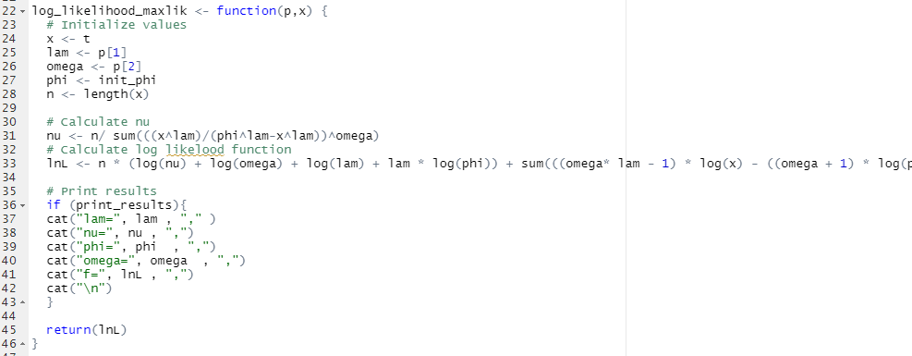



Python code was mainly used for data visualization and providing clean plots for the data and final results. For instance, a correlogram using the Seaborn library in Python in order to characterize the data and determine if there were any initial correlations that could be found between any of the columns for each sample. Furthermore, this was used as a simple way to create plots to overlay the PDF, CDF and hazard functions of the results and calculated from the data, along with easy addition and manipulation of text boxes and legends. Below are examples of such code.

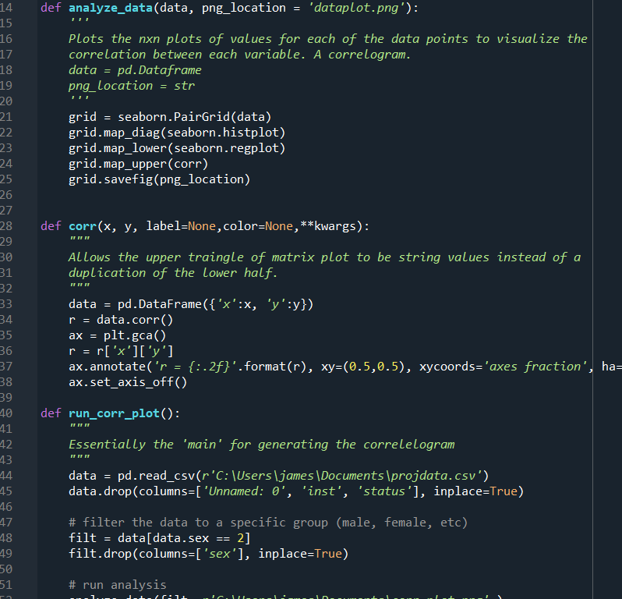

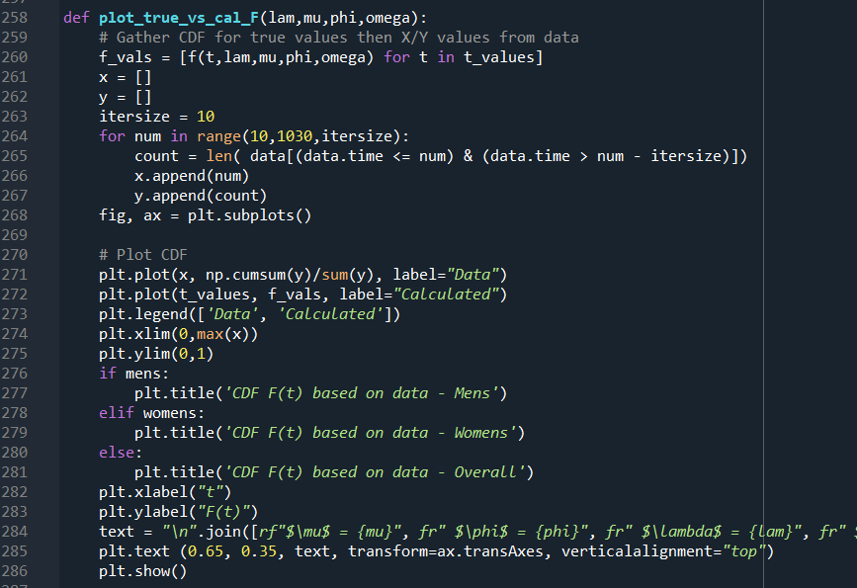

# Results

## MLE Convergence Verification

Since convergence of these two parameters could not be verified analytically, visual analysis of the two parameters gives the following graphs for the MLE:

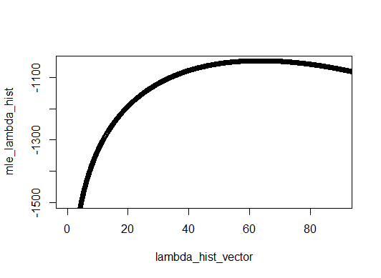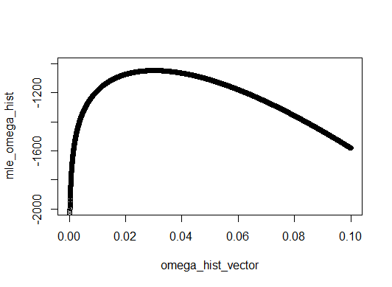

Using these graphs and the equations calculated previously, clearly the MLE values are non-monotonic with a clear maximum value somewhere in the aforementioned range for the two parameters. Using larger values for either of these parameters results in breaks within the optimization code, and inevitably divergence from the true solution.

Before simplification of the φ value, convergence values started higher than 1022 and 965 for the men’s and women’s datasets, respectively, since it was for these values that the PDF was defined. Surprisingly, the optimizer would set φ to be almost equal to values equal to the maximum of the times of the dataset. The graph below visually proves this concept for each iteration of an example optimization. More examples of this graph are shown in the Appendix with different starting values and the 3 different data sets (overall, mens, and womens).

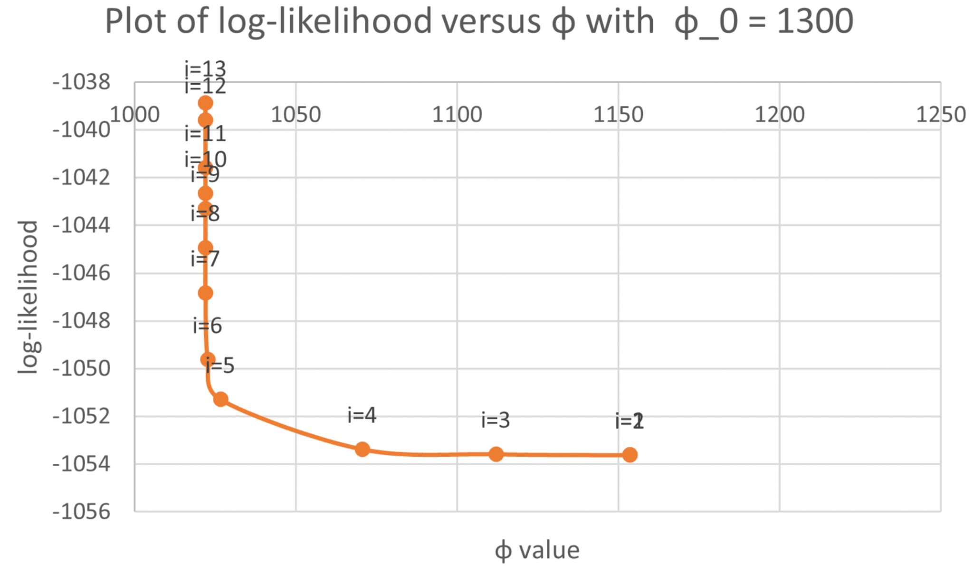

## Estimated Parameters and Data Fitting

One attempt at optimization is to keep some of the variables constant, and then optimize the parameters one at a time. The results for this style of testing are shown below.

| **Ind. Optimized Parameter Value** | **Combined** | **Male** | **Female** |
| --- | --- | --- | --- |
| $λ$ | 63.3251 | 57.8361 | 75.1015 |
| $φ$ | ~1022 | ~1022 | ~965 |
| $ω$ | 0.03012 | 0.02755 | 0.03578 |

However, the more accurate technique to perform optimization is done by optimizing all the parameters at the same time. When simplifying MLE to be a function of only $ω$ and $λ$ and then performing the optimization, we arrive at the following results below.

| **Parameter Values** | **Combined** | **Male** | **Female** |
| --- | --- | --- | --- |
| 𝞴 | 50.66104 | 48.43294 | 38.4 |
| 𝝋 | ~1022 | ~1022 | ~965 |
| 𝛚 | 0.02626212 | 0.02718752 | 0.03818065 |
| $ν$ | 4.477732 | 4.753729 | 3.93184 |
| Max ln(MLE) | -1037.059 | -614.063 | -402.5507 |

All the values above seem fairly consistent in their ranges. It will be seen that the overall results are very close to the male dataset, which directly correlates with the fact that the dataset had a much higher number of men rather than females for the samples. Regardless, all the results look

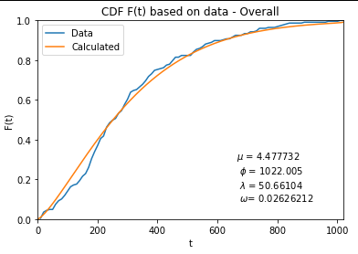

As seen above, the CDF from the optimized parameters above are very accurate in comparison to the CDF obtained from the data. This further proves the accuracy of methods that were used for this experiment, and that the final results for the optimization were as close to the maximum MLE as possibly computed.

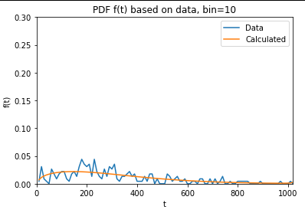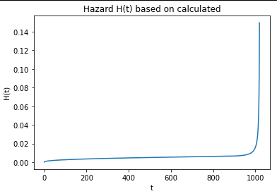

As seen above, there is a (somewhat) accurate PDF in comparison to the data. PDF’s are harder to plot (especially with using the data) since the PDF is using a continuous domain, which in theory always makes the probability at any specific time value always equal to 0. Thus, these plots assume a specific bin size (as shown in the title) to approximate the graph for the PDF.

## Comparing the 3 Datasets

When comparing all three datasets (overall, men, and female), several conclusions can be seen:

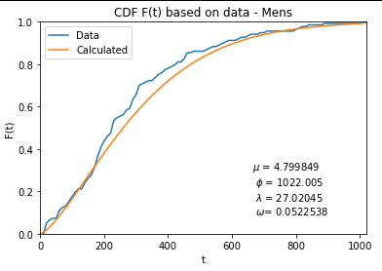

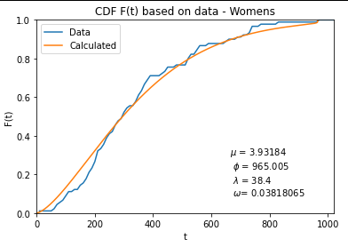

| **Dataset** | **Overall** | **Mens** | **Womens** |
| --- | --- | --- | --- |
| **SSE** | 0.043998 | 0.161910 | 0.280258 |

As seen from the graphs and sum of squared errors (SSE) above, the CDF has a higher error on the women’s side than on the men’s side, and this is most likely due to the lower number of samples from women than from the men. However, despite these errors, the resulting CDFs still visually appear to be good fits for the data.

An additional test that was performed was a Smirnov-Kolmogorov test to see if the two samples (the data and our model) come from the same distribution. The Smirnov-Kolmogorov test is a sort of “goodness of fit” test commonly used to determine whether the CDF’s of two samples belong to the same distribution. In the case of the project, the CDF was generated using the “create-cdf” function in R, and then

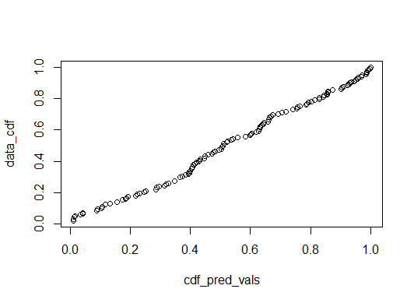

PDF Comparison

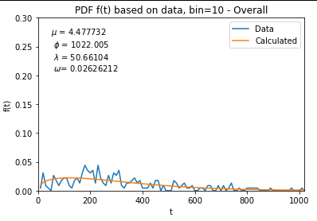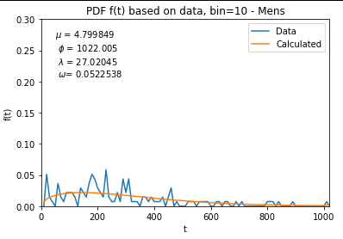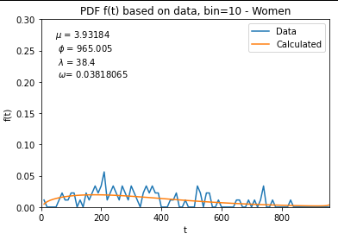

As seen above, the PDF seems to be very “jagged”, and this is because there is a small bin associated with these PDF y values. This method is needed due to the fact that the probability of dying instantaneously at a single point in time is essentially zero. Rather, ranges of times were used to try to visualize the PDFs. Regardless, the results seem somewhat representative and it would appear that this graph is not as useful for modeling as compared to the CDF and the hazard rate.

Hazard Comparison

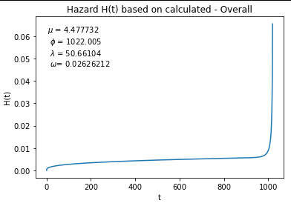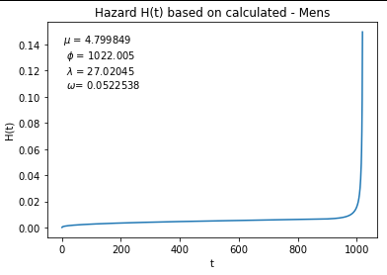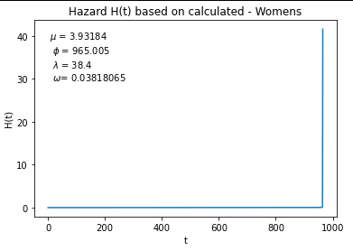

As seen above, all of the hazard plots share the same gradually-increasing shape (as opposed to the alternate bathtub shape). The main difference between all three plots is the size of the range. Particularly, the women’s plot is scaled so much larger that the shape appears to be an exact backwards “L”.

# 

# Discussions/Conclusion

## Conclusion

Future efforts regarding this data and the models related to it could involve additional, perhaps more sophisticated ways of optimization, a more comprehensive exploration of the search space, a collection of more data to validate and perhaps enhance existing results, and finally, perhaps the consideration of whether the Weibull Power Function really is a good fit for the data. The optimization method used made the use of two R functions whose implementations are presently unknown to the authors. Without a doubt, there are more efficient and comprehensive ways of optimizing the log-likelihood function. To name a few, some methods that could be considered for optimization include: gradient descent and its variations such as accelerated gradient descent, the ADAM optimizer, RMSProp, etc…

In addition, something else that must be considered is that the search space that has been explored in this project is fairly small. The search space was explored on the basis of technical limitations. For example, a part of the decisions that were made for exploring some of the variables were made on the basis of technical limitations related to the accuracy of the data types used. Moreover, perhaps using some data types with more floating point precision could lead to less overflows, underflows, and NaNs as seen in this project’s efforts. Last but not least, this entire approach could be subjected to examination, as the distribution that we have chosen may in fact, not be a good fit. We have considered some errors with regards to the CDF, but there are other comparisons that could be made to other distributions that perhaps model the data in a more comprehensive way.

One notable lesson we learned in this project is the importance of analyzing the data beforehand using techniques such as the correlogram.

## Challenges

One major challenge encountered during the optimization portion of the project was encountering NaNs (overflows, underflows, or in rare cases, divisions by zero) in the function and gradient evaluations, which would often cause problems in the optimizers. Specifically, R’s optim function was ill-suited for finding the values for convergences as it would always return values for parameters which were clearly not optimal. As a result, alternative logging within the evaluated log-likelihood function helped determine which converged values caused the maximum value for the log-likelihood.

As a result of these issues, the maxLik function was used. However, this would also frequently get NaNs in the gradient, despite continually returning consistent and accurate parameter values more consistently than optim. Thus, the optim function was abandoned for the imported maxLik function.

# References

The Weibull-power function distribution with applications - M. H. Tahir∗ , Morad Alizadeh , M. Mansoor , Gauss M. Cordeiro and M. Zubairk

Wackerly, D. D., Mendenhall, W., & Scheaffer, R. L. (2012). *Mathematical statistics with applications*. Brooks/Cole.

*Package maxlik - cran.r-project.org*. (n.d.). Retrieved December 7, 2022, from <https://cran.r-project.org/web/packages/maxLik/maxLik.pdf>

*Karnofsky Performance Status Scale definitions rating (%) criteria - NPCRC*. (n.d.). Retrieved December 7, 2022, from http://www.npcrc.org/files/news/karnofsky_performance_scale.pdf

Bell, D. J. (2021, August 31). *ECOG performance status: Radiology reference article*. Radiopaedia Blog RSS. Retrieved December 7, 2022, from https://radiopaedia.org/articles/ecog-performance-status?lang=us#:~:text=The%20ECOG%20performance%20status%20is,form%20the%20BCLC%20HCC%20staging).

# Appendix

## Phi Convergence Graphs

See below for a visual representation proving convergence for each dataset regardless of the initial value of phi.

Convergence of Phi for complete dataset:

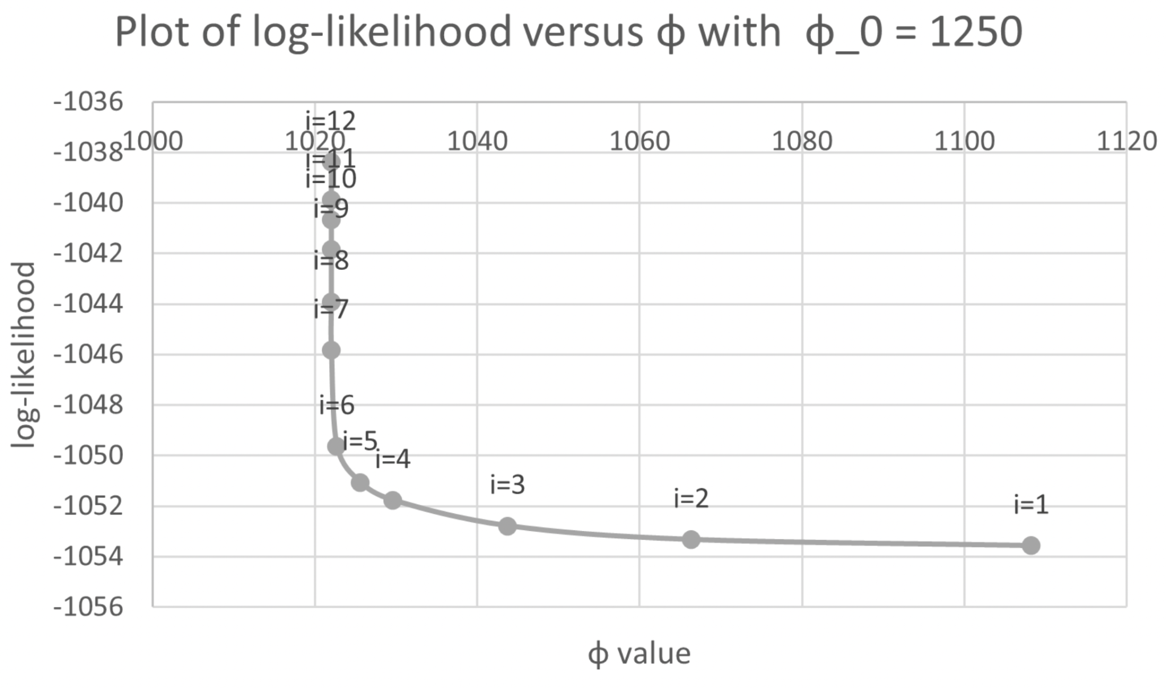

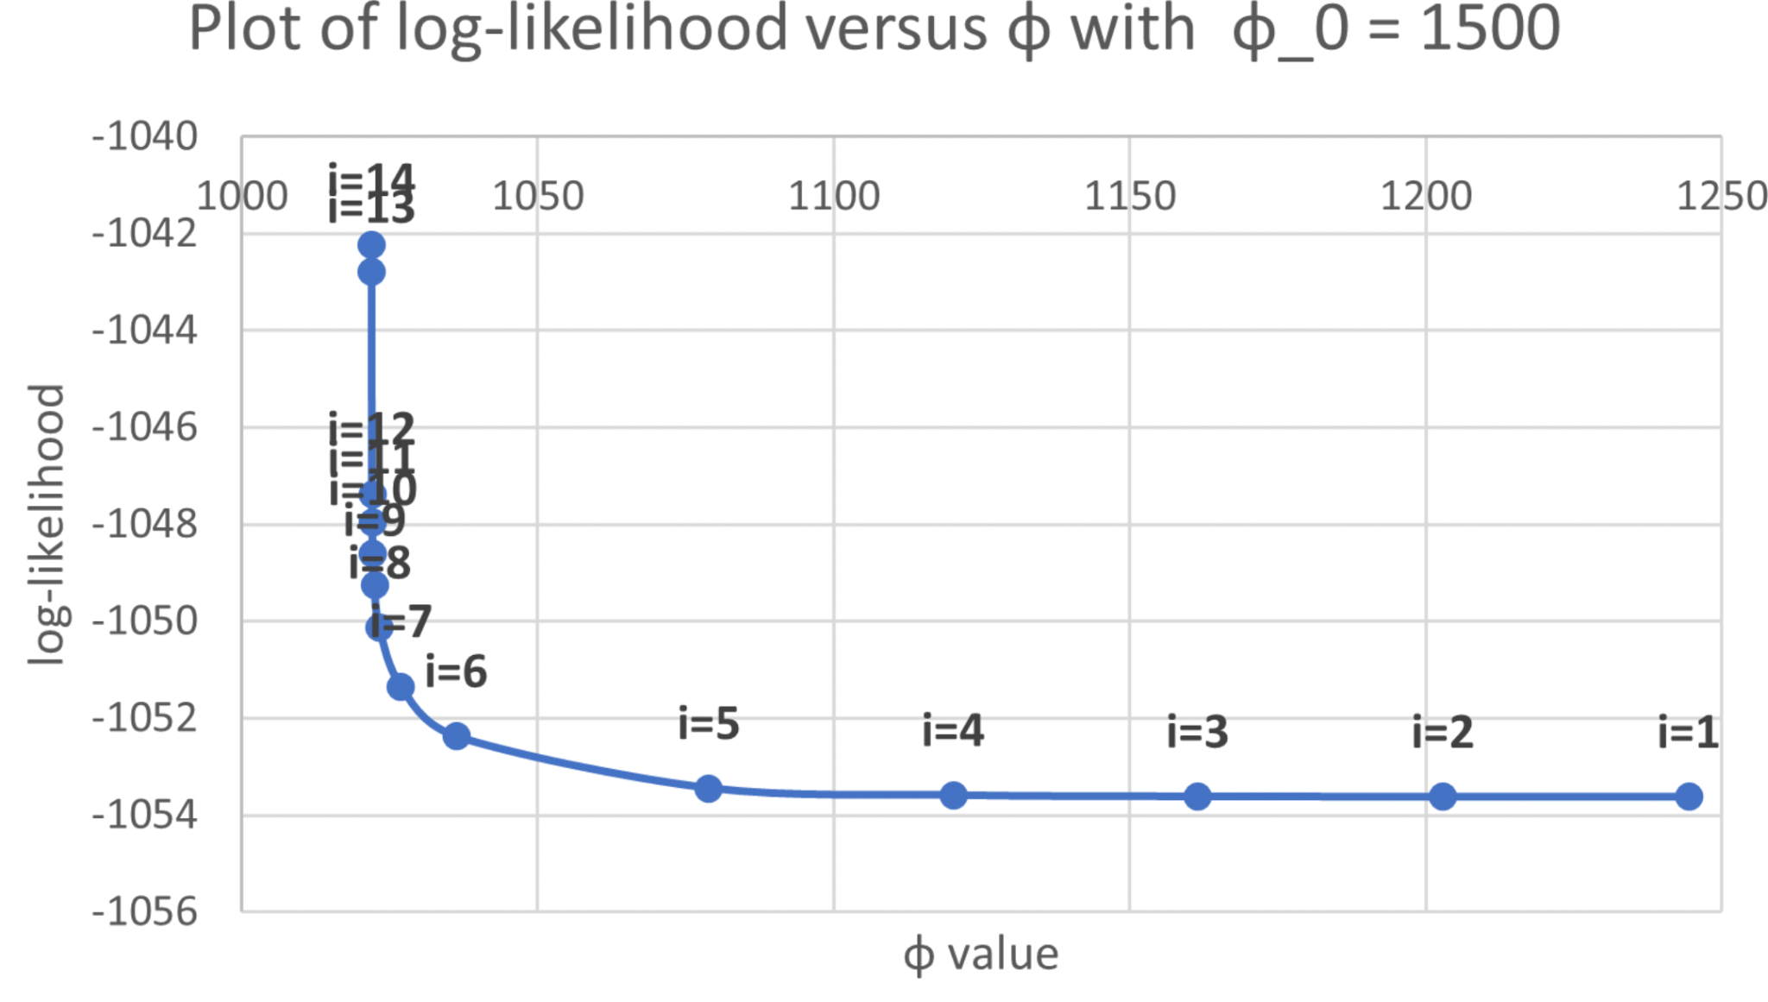

Convergence of Phi for women data in dataset:

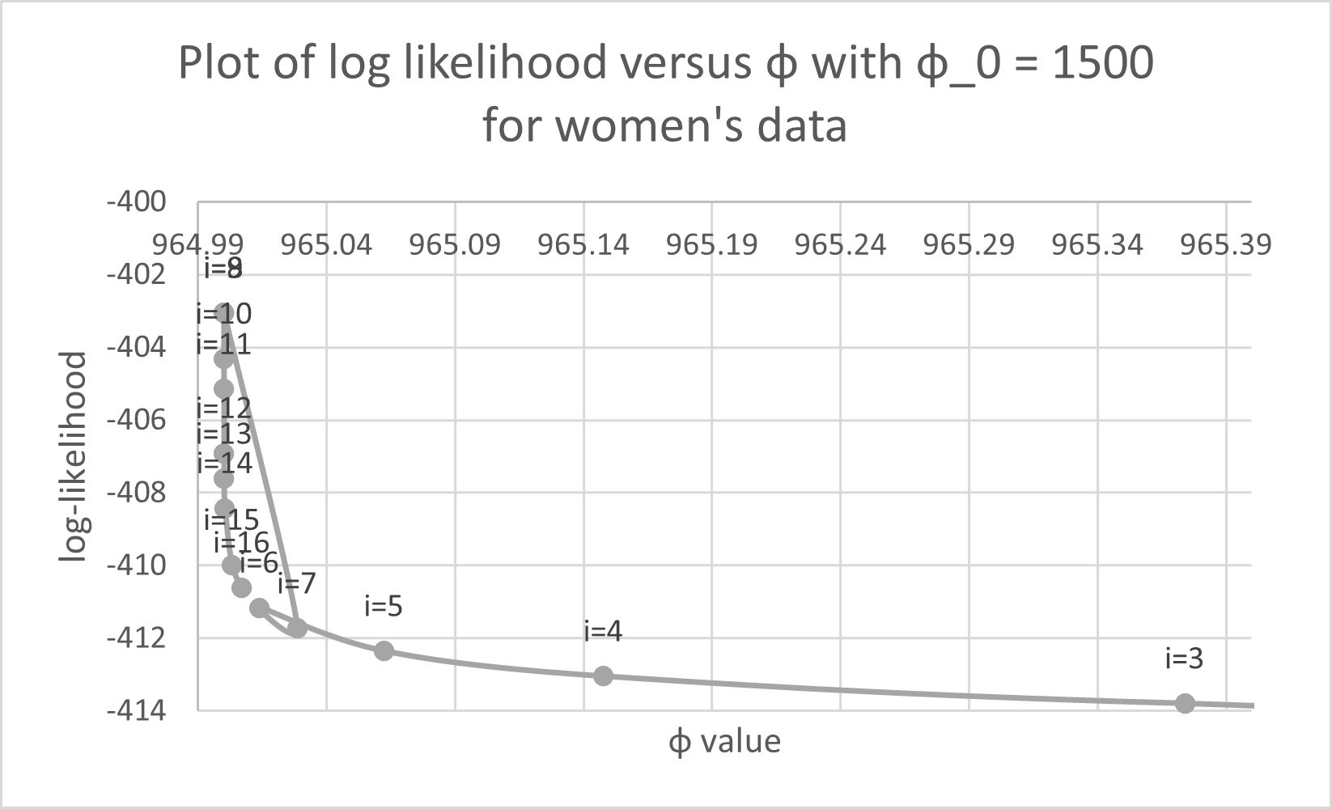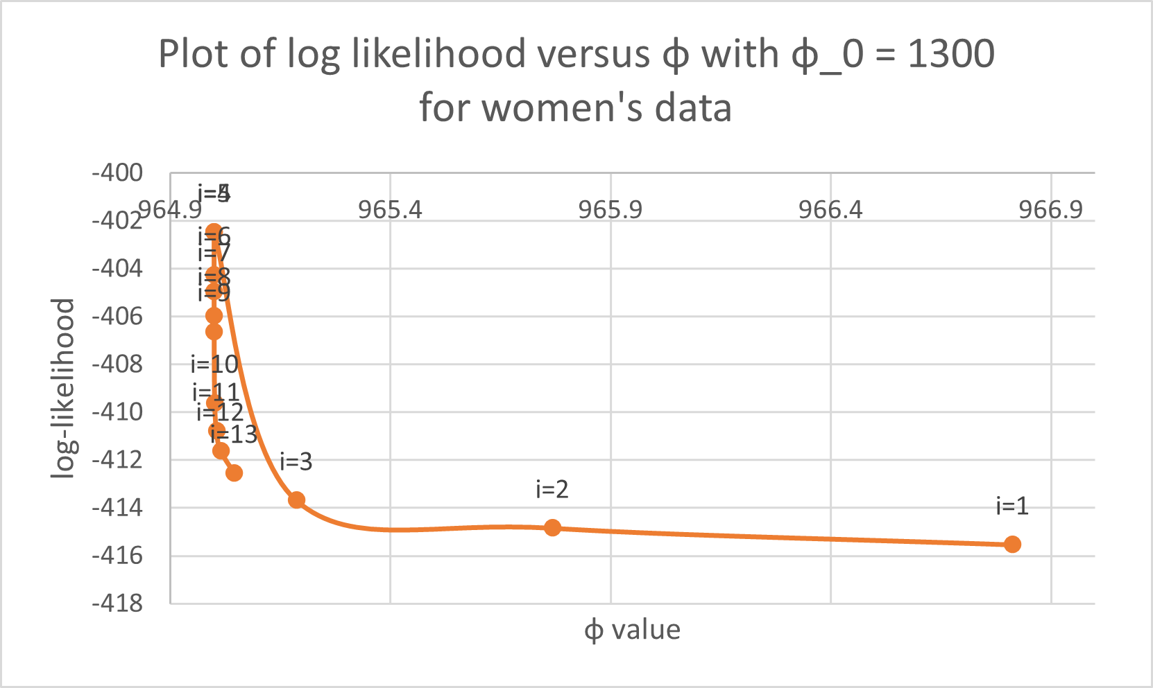

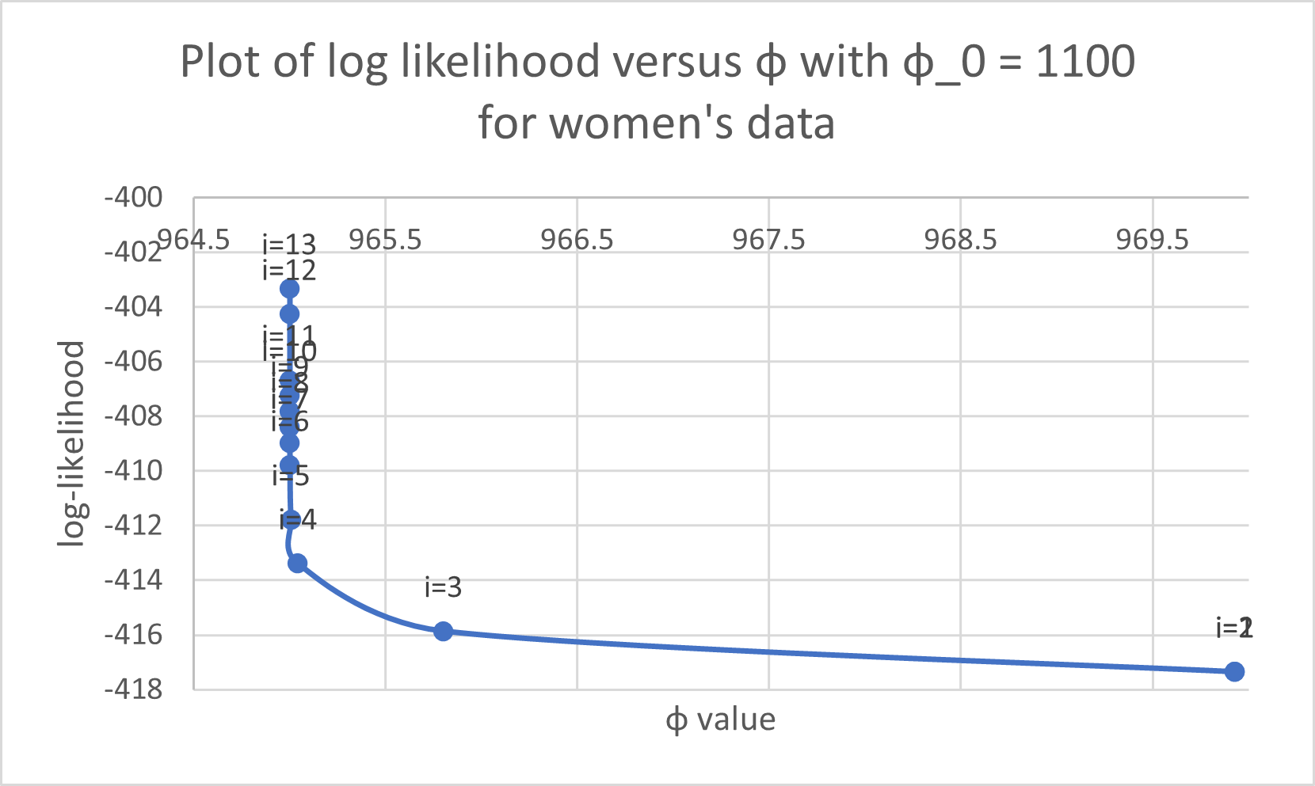

Convergence of Phi for men’s data in dataset:

